President Morgan, Board Members and all others in attendance today. Please accept the following items as part of my report:

- Student Count as of 2/25/17

- Staffing for next year – We are in the process of interviewing to look at staffing needs for next year. Currently we have 9 openings — 7 teaching positions and 2 district office positions. We hope to hire as many as possible prior to the Job Fair in Anchorage. The Job Fair is at the Captain Cook Hotel from March 16 - March 18. Updated information will be available at the next board meeting in April.
 | PK3 | PK4 | K | 1 | 2 | 3 | 4 | 5 | 6 | 7 | 8 | 9 | 10 | 11 | 12 | Total in Blg | OASIS Count
AMNES | 6 | 10 | 11 | 16 | 16 | 12 | 14 | 6 | 7 |  |  |  |  |  |  | 98 | 82
AJSHS |  |  |  |  |  |  |  |  |  | 10 | 4 | 12 | 8 | 14 | 5 | 53 | 53
Total Aniak | 6 | 10 | 11 | 16 | 16 | 12 | 14 | 6 | 7 | 10 | 4 | 12 | 8 | 14 | 5 | 151 | 135
CVSS | 3 | 1 | 3 | 1 | 4 | 2 | 1 | 2 | 3 | 1 | 1 | 1 | 2 | 1 | 1 | 27 | 23
JJSS | 1 | 4 | 3 | 1 | 1 | 4 | 3 | 2 | 0 | 2 | 2 | 2 | 0 | 0 | 1 | 26 | 22
JESS | 1 | 5 | 2 | 1 | 3 | 1 | 0 | 1 | 1 | 2 | 0 | 0 | 1 | 0 | 2 | 20 | 14
GMS | 1 | 2 | 2 | 1 | 4 | 2 | 0 | 0 | 0 | 0 | 1 | 1 | 0 | 0 | 0 | 14 | 11
Total UpRiver | 6 | 12 | 10 | 4 | 12 | 9 | 4 | 5 | 4 | 5 | 4 | 4 | 3 | 1 | 4 | 87 | 70
JOGES | 11 | 14 | 18 | 11 | 13 |  |  |  |  |  |  |  |  |  |  | 67 | 45
ZLES |  |  |  |  |  | 16 | 15 | 7 | 5 |  |  |  |  |  |  | 43 | 43
GMSHS |  |  |  |  |  |  |  |  |  | 11 | 7 | 11 | 11 | 3 | 5 | 48 | 48
Total Kalskag | 11 | 14 | 18 | 11 | 13 | 16 | 15 | 7 | 5 | 11 | 7 | 11 | 11 | 3 | 5 | 158 | 136
Total District | 23 | 36 | 39 | 31 | 41 | 37 | 33 | 18 | 16 | 26 | 15 | 27 | 22 | 18 | 14 | 396 | 341
Sub Totals | 59 |  | 215 |  |  |  |  |  |  | 122
 | PK Total |  | K-6 Total |  |  |  |  |  |  | 7-12 Total

- Reminder of Spring Break – begins after school gets out on Friday March 10th through the beginning of school on Monday March 20th. I hope that this week off gives everyone a chance to recharge their batteries for the push towards the April testing window as well as the finishing out the school year on a strong note with graduations and other culminating ceremonies.
- Spring testing – (Now known as PEAK) will be taking place across the district the weeks of March 27th –31st with make up testing occurring the following week of April 3rd– 7th. Reminders will be sent out to students, parents and community members that we will be pushing hard to work with students on our last efforts to get ready for this very important testing time. Reminders will go out from the schools as we return from spring break about testing dates and times as well as suggestions to help get students ready for testing dates with a good nights sleep, eating a good breakfast as well as test takers taking their time and trying their best on these state mandated assessments. This cycle of testing for grades 3rd – 10th will be conducted using pencil and paper and not on line. While we anticipate that our students will do their best on these new assessments, we also realize that the increased rigor will cause potential drops in the proficiencies of all students state-wide – especially since this was a different test than we offered two years ago. This potential drop doesn’t mean our students are not learning but are being assessed on a completely different, more rigorous set of standards.
- Decathlon – We are going to have another Decathlon this year. It will be from Tuesday May 2nd through Friday May 5th. This will affect all grades 7-12. We will have a career fair during this time. Other Students from LKSD, Kashunamiut, LYSD, and St. Mary’s will be participating in this. We anticipate 130 to 180 students.
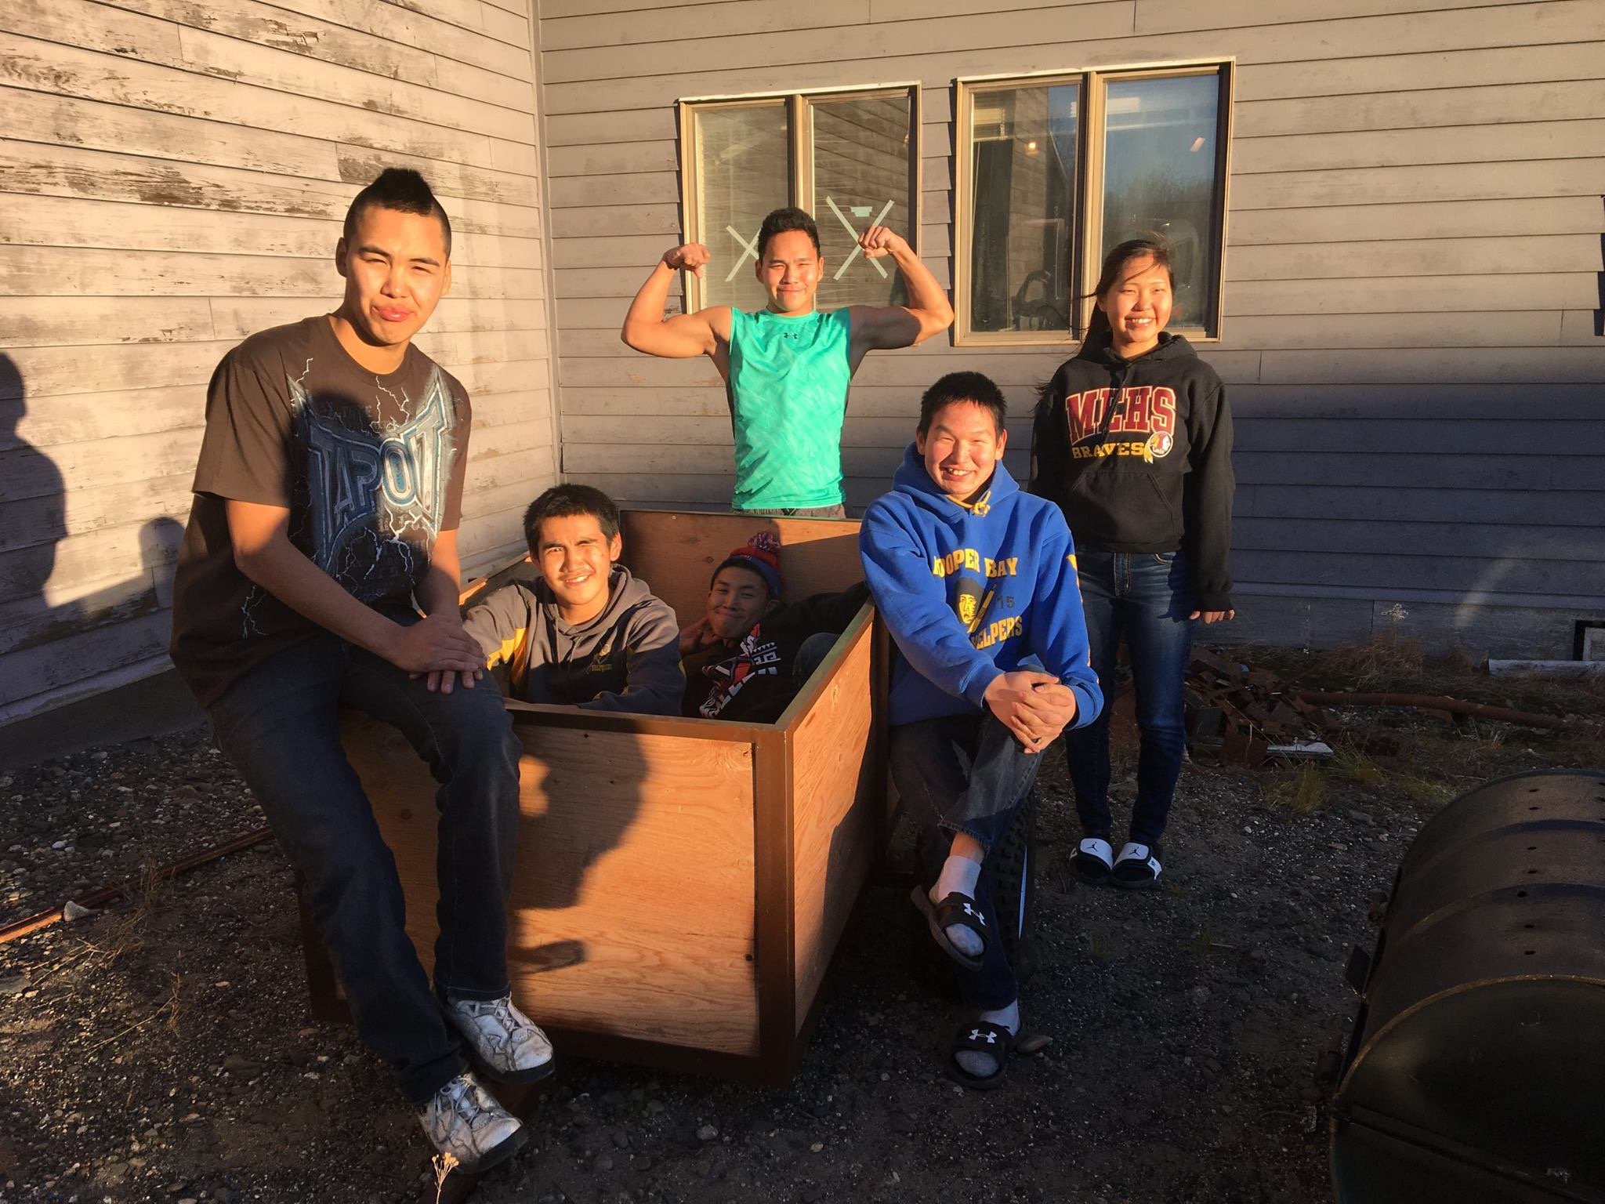
- Graduations —Although I posted in my last report, Below is the list of dates for graduations at each of our sites:
  - Saturday May13th – Johnnie John Sr. School – time to be determined
  - Monday May 15th – Jack Egnaty Sr. School – time to be determined
  - Friday May 19th – George Morgan Sr. High School – time to be determined
  - Saturday May 20th – Aniak Jr. Sr. High School – time to be determined
  - As of this time, no graduations will take place in Chuathbaluk and Stony River as there are no graduating seniors in those villages
- Summer Clean Up Project around Joe Parent – ADOT has contracted with Olgoonik Specialty Contractors and SLR to conduct the PCB cleanup work. We discussed earlier this week to discuss the project, preliminary schedule. It is my understanding that they will be digging up much of the gravel between the Joe Parent and the High School. Also after discussing with Jeromy, we find it unlikely that Maintenance will have vehicle access to the bus barn, cold storage or the runway side of the Joe Parent Building. On a side note, they plan to lease the Joe Parent Building from us and use our local cooks and janitors for 6-8 weeks.
- Vehicle Purchases - In plan to begin to replace our fleet of aging 20 year + district vehicles, I’ve been working with the budget committee to purchase a new vehicle to replace the one that is in the worst shape and retiring it. In addition to this purchase, we will need to have two vans with wheel chair access ramps / lifts in two of our villages to meet the needs of the anticipated intensive needs students enrolling next year. We have worked with a company in Oregon to put together the necessary package and have them shipped from the factory to Portland where they will be converted to 4-wheel drive and then to Seattle where they will be barged to the Kuskokwim. We purchased 2 - 2017 GMC Savanas and a 2017 GMC suburban. The oldest vehicle in the district will be retired and sold in a silent bid auction soon.

Attached is a report from Tony Wilson who has been working individually with each senior in the district.

Kuspuk School District and EXCEL Alaska Lead Teacher Tony Wilson has been working with the senior students at each site to get them on a plan of action after they graduate. I went to each school site to work with the seniors. I spent two days in Kalskag, one day in Chuathbaluk, one day in Sleetmute and one day in Aniak. While working with the seniors, we got quite a bit accomplished. Below is a list of things that we worked on and the students are trying to complete.

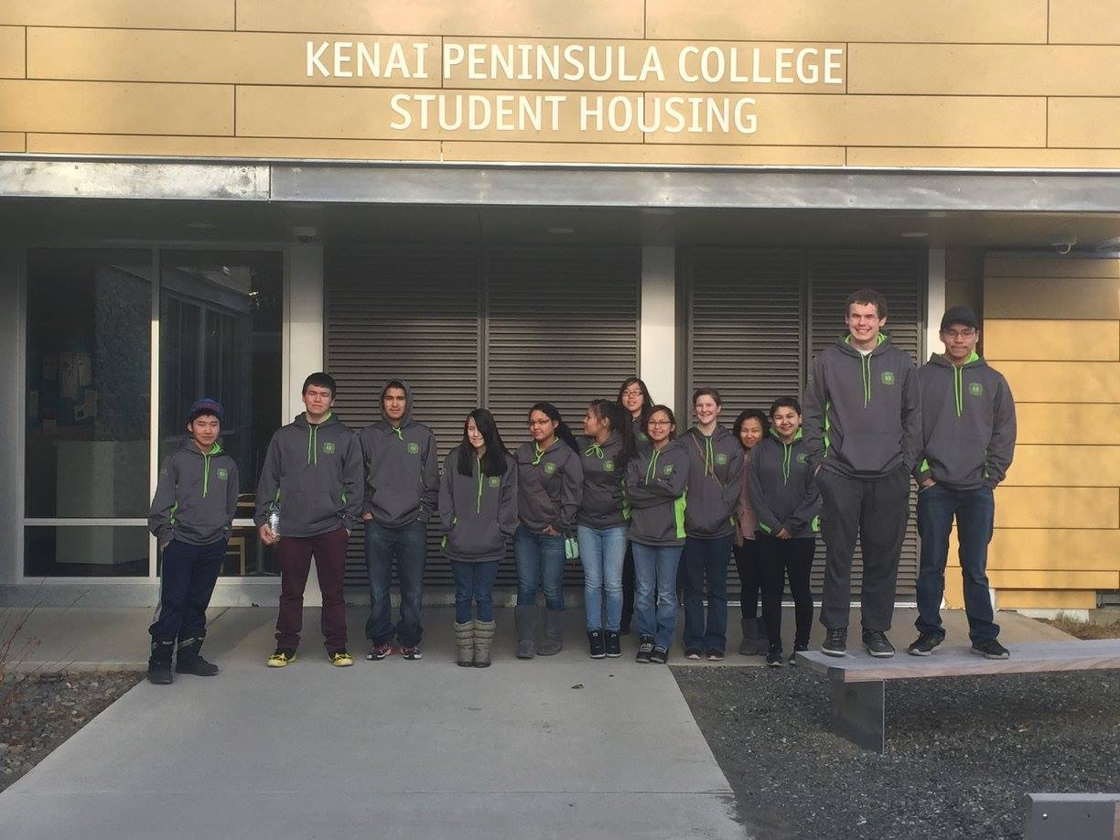
First thing I had the students do was to set goals. We used the SMART (Specific, Measurable, Attainable, Relevant, Time) goal method to help them set their goals. They had to set a weekly goal, a monthly goal, and a yearly goal. All the students completed this and have some really nice goals. Here are a couple examples. Marissa’s weekly goal is to be at school every day and fill out as many scholarships as possible. Leonard’s monthly goal is to have perfect attendance for one whole month. Samuel’s yearly goal is to be in the Navy and be finished with basic training.
Students also worked on AKCIS. AKCIS is an online career planning website that allows students to figure out what they are interested in. There are eight total assignments that they are working on completing. They will give me a completed packet when I work with them the week of March 6-10.
Students also started filling out applications to colleges, trade schools and contacted recruiters about entering the military. Kalskag senior Marissa Abarca plans on going to UAA and working through the Criminal Justice Program. Marian Wise is working on applying for AVTEC. Terrell Mute is interested in attending Job Corps, NIT and AVTEC. Isaac Evan is planning on joining the ARMY and Reshelle Alexie will be attending Job Corps. Brenton Berry, who is living in Chuathbaluk, is working on his Job Corps application for Automotive Technology, which if accepted will go to Job Corps in Hawaii. Sleetmute senior Samuel Mellick is planning on joining the Navy as a Corp man, which is a Navy medic. Madison Dooley is planning on joining the workforce. Aniak senior Carly Kelila is also planning on joining the NAVY. Matthew Morgan (Electrical Program) and Leonard Morgan (Building Construction Technology Program) are planning on Job Corps and Ray Turner is undecided.
Marissa and Marian have also been working on filling out scholarship applications, as well as, FAFSA. These two are also working on their scholarship essays and letters of recommendation.
Students that are planning on attending Job Corps are working on their applications.
Students will also complete a mock budget to help them manage their money. This is a work in progress.
Students interested in AVTEC are studying for their TABE test and are also applying to EXCEL Alaska’s AVTEC mini-bridging session. They can take the TABE test while they are there.
Students interested in the military are studying for the ASVAB and have the opportunity to attend EXCEL 12 in April to take it and meet with a recruiter.
Job Corps applicants will also have the opportunity to attend EXCEL 12 to take a trip to Job Corps in Palmer.

I will be traveling to Kalskag on March 6th, Sleetmute March 7th, Crooked Creek March 8th, Chuathbaluk March 9th and Aniak March 10th to work with the seniors again. Megan Leary of TKC and Audrey Leary of AVCP will be traveling with me to help the seniors finish what they need to be successful.

If you are interested in EXCEL Alaska’s schedule for the spring, please view at www.excelalaska.com

Reported by Tony Wilson

This concludes my report for this month. I will be happy to answer any questions that you may have concerning this or other items.
Thank you,
Erich Kuball
Interim Superintendent – Kuspuk School District

