MKEA “Highlighting” November 9, 2017
Submitted by: Jodi Darling

MKEA

The Annual NEA Fall conference was held in October. MKEA was represented by six members that attended. They received valuable training on ACE’s, culture in the classroom, technology in the classroom, and social injustice that will be utilized at their schools.

JESS

As usual, it has been a very busy month of October in Sleetmute. Sheree and Angela kicked off the month by travelling home from the Alaska Cross Content Conference in Fairbanks. We thoroughly enjoyed the speakers and took home so much that we have already begun to use in our classrooms.

Students were able to enjoy their first Distance Learning Session with the Alaska Sealife Center. Students chose the “Ring of Fire” session that taught them about plate tectonics and volcanoes both in Alaska and around the world.
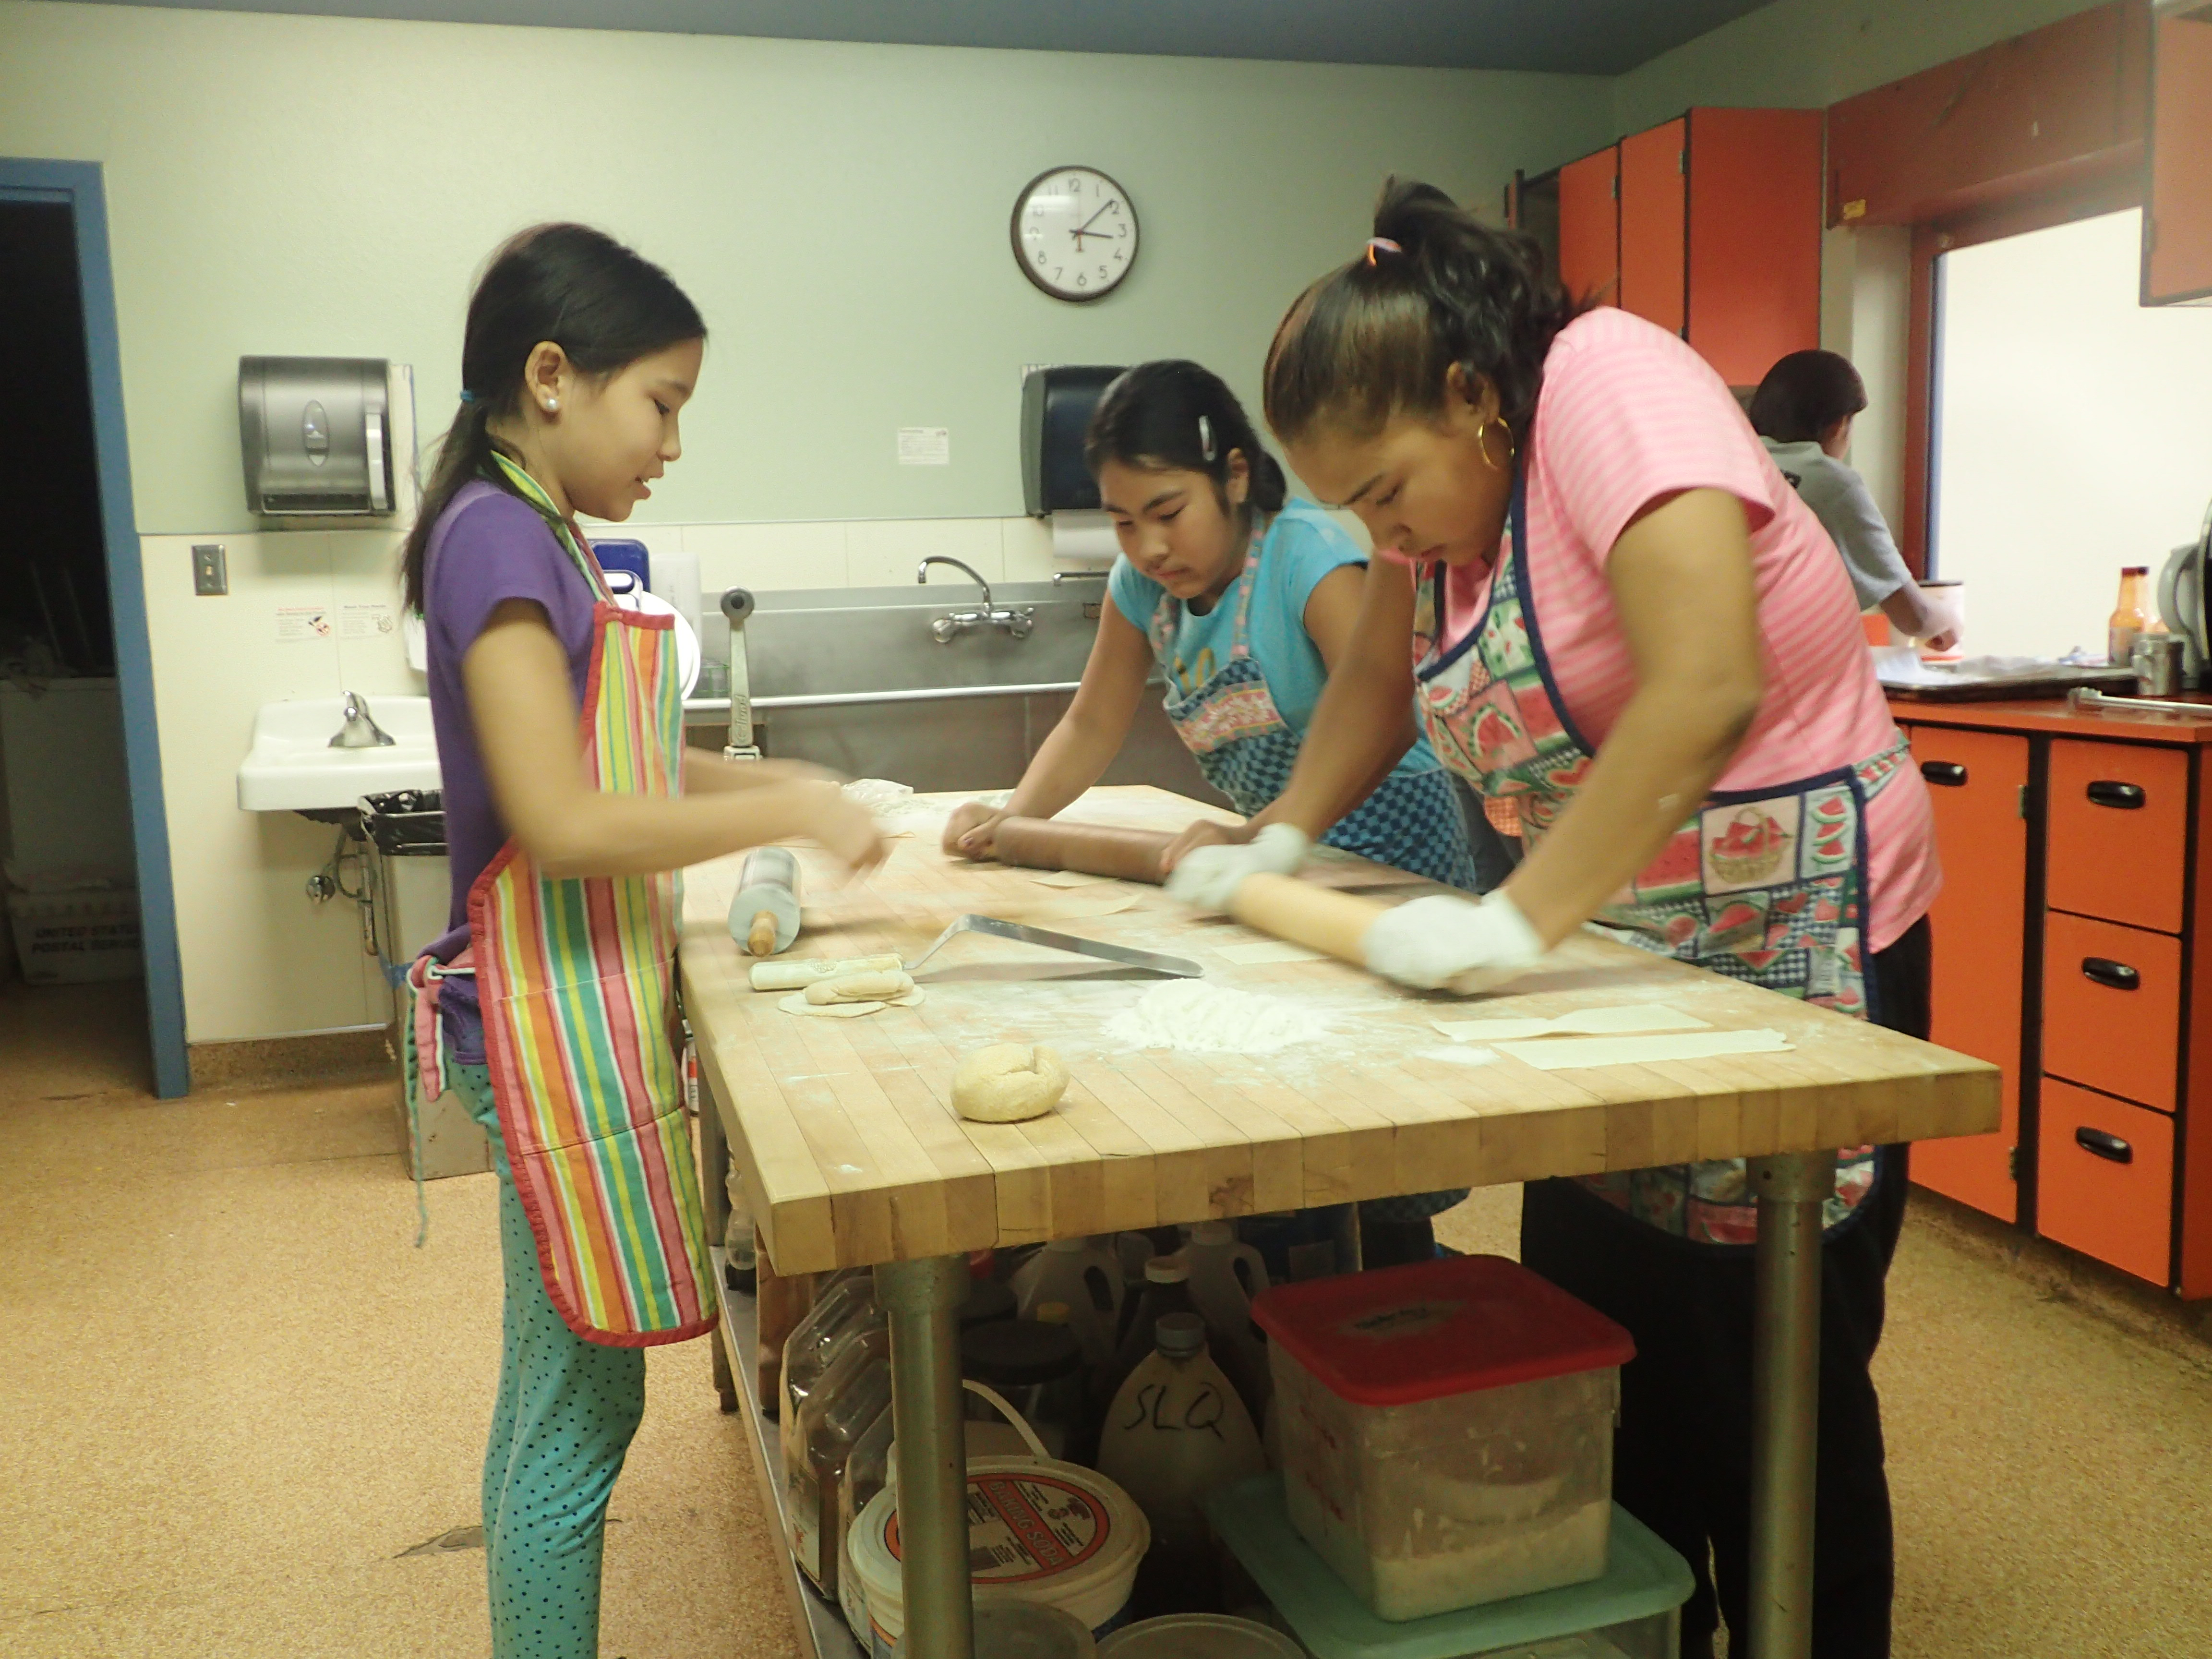
Students have begun working on community service projects for the year. We have some students tutoring younger students, improving the airport shelter, painting to spruce up the community center, and much more. The students make us so proud with the work they do to make Sleetmute a better place to live.

Students have been taking advantage of the elective classes offered this semester. The Home Economics class has been learning basic cake decorating and has successfully completed two layered cakes and some
delicious filled cupcakes. They are working on making homemade lasagna to sell on Halloween. They have made the ricotta and mozzarella cheeses and will even make the noodles by hand.

The music class is sounding better everyday. Students are learning the violin and the cello and have been working on Moana songs to play for our Hawaiian Luau in November. A younger student has been practicing keeping rhythm using the native drum purchased by Cheryl Jerabek years ago. It is a great addition to our orchestra.
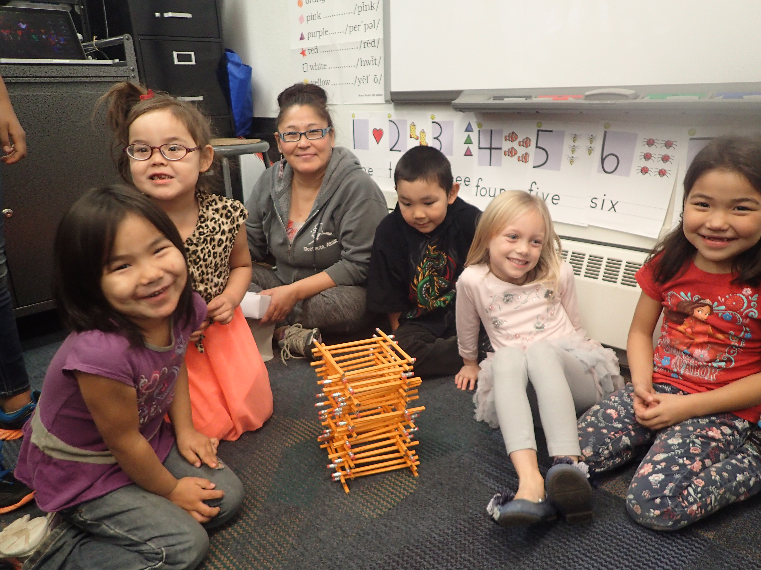
The third elective class is physical education. Students have been learning about following directions and maintaining personal fitness.

Jack Egnaty Sr. School also has 4 Battle of the Books teams in full swing. Students are reading fervently and already practicing for their first practice battle in a few weeks.

We have been holding Parent Teacher Conferences to inform parents on the new report cards and get them signed up for PowerSchool to see their student’s grades online. We had a few glitches so the process is slow and we haven’t been able to get any feedback as of yet. We’ll see how it progresses and give more feedback next time.

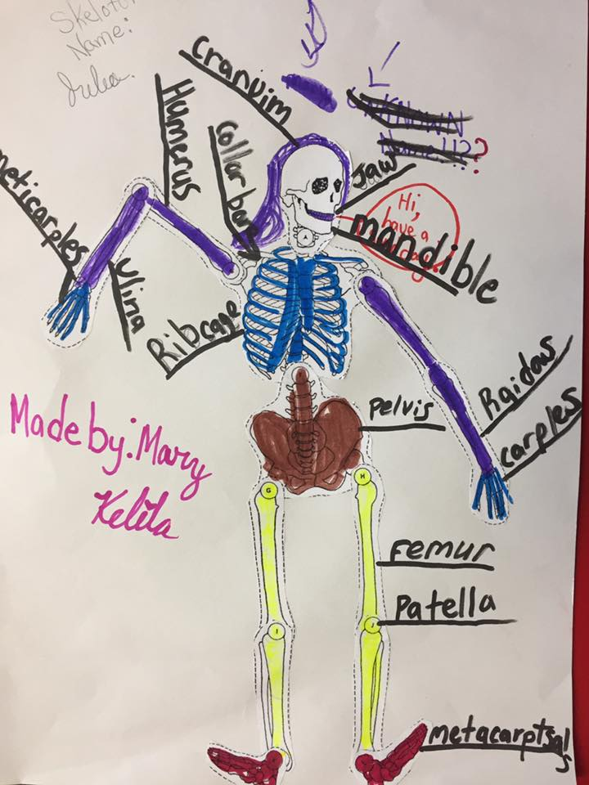
AMNES

Ms. Boynton's 5th/6th grade students completed the Candy Corn Tower Challenge Students worked in groups to develop the tallest tower using only a cup of candy corn and toothpicks.

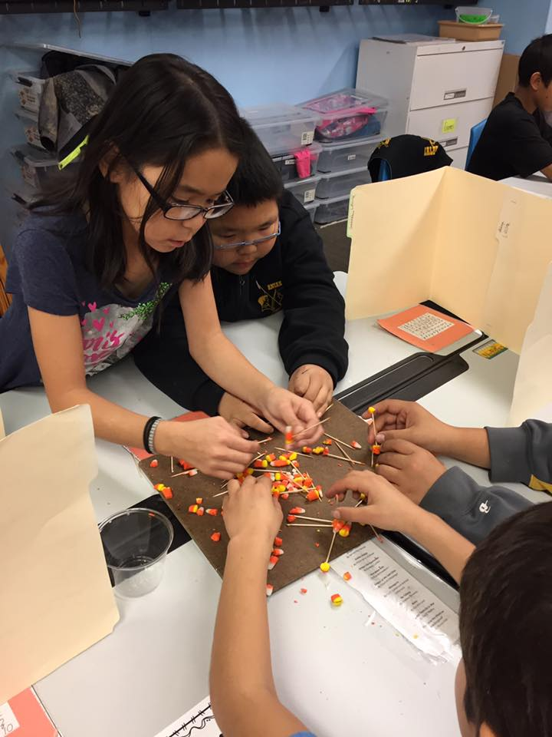
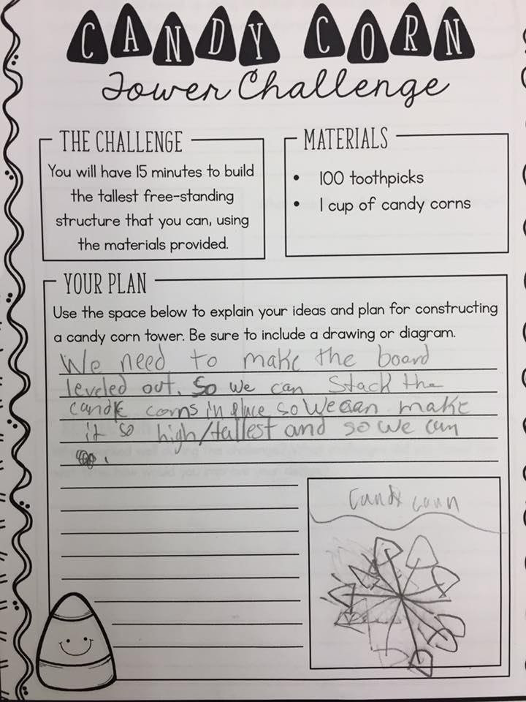

Students in Ms. Boynton's class are learning about the Skeletal System in Science Class.

